**ICS4U1 Final Project Instruction Guide**

### By Tim Ruscica & Nick [Tkachov](https://github.com/nick-tkachov) Jan 24, 2017

Table of Contents:

Page 1: Initial Setup & Running the Program

Page 2: Signing in & Creating an Account

Page 3: Playing Games

Page 4: Profile & Community Profiles

Page 5: Adding Friends

Page 6: Global & Friend Leaderboards

Page 7: Instant Messaging

Initial Setup & Running the Program

**Running the Program**

All the files included in .zip file uploaded to the moodle are required for the program to run. The program consists of many files and folders but the only file that should by ran is the “run.pyw” file located in the main directory (see images below). To avoid possible issues please run this file from IDLE python interpreter. Please note that this program should work with all versions of python past V 3.5.

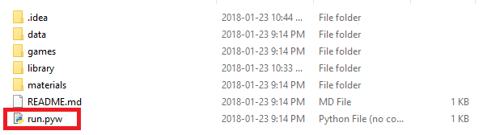

**Program Dependencies**

As this program stores information using Amazon Web Services it is required that certain packages and modules are installed. On your first run of the program you should see a screen showing that certain packages are being downloaded (Boto3, Pip, etc.). This will take a few minutes so please wait for the modules/packages to be installed.

**Storage**

The downloaded .zip file must be extracted first to run the program. Please ensure that the main directory is not altered in any way and all the files stay in the same location as they were found originally. The main directory may be saved in any location you desire. The directory should take up about 11-12mb.

Signing In & Creating an Account

**Creating an Account**

If this is your first time using our program, please start by creating an account. From the sign in window click on the prompt, “Don’t have an account? Sign up here!” and proceed to enter your information. Once you have clicked submit you will be asked to sign into your account in the next window.

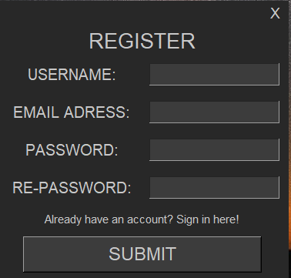

**Signing In**

Once you have successfully launched the program you should be prompted with a sign in window. To sign into your account simply type in your username and password and click the submit button. It will take a few seconds to validate your account and if your credentials are correct you will be directed to the main launcher window.

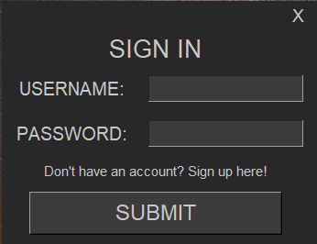

Playing Games

**The Library Tab**

Now that you have created and signed into your account you can start to use the launcher to play games. Currently there are two games available to play (golf game is under development). To see the list of the games, click on the “LIBRARY” tab on the top menu panel. This will show you buttons on the side of the screen with a list of games. Simply click on the game you desire to play and then click on the “PLAY” button shown to run the game.

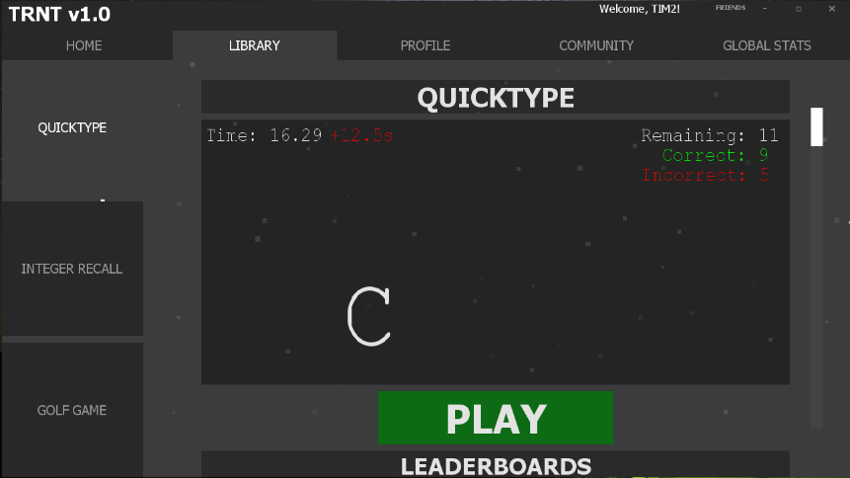

**Game Statistics**

While playing a game your score, time played, and games played will be recorded. You can see this information in game or by scrolling down on the window showed above. It will show you a friend leaderboard with your scores in relation to theirs. You can also see your statistics by going to your profile (Page 4).

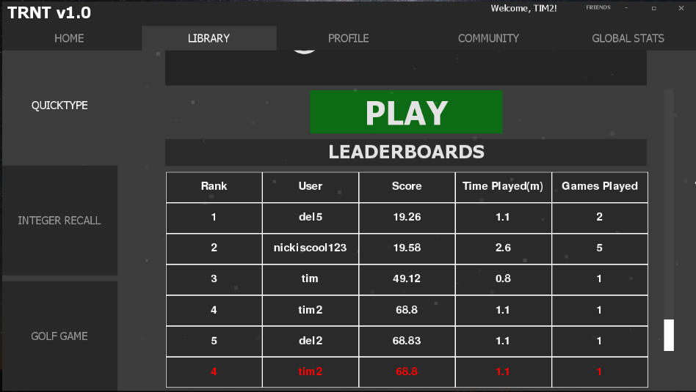

Profile & Community Profiles

**Personal Profile**

To view your own player profile simply click on the tab labelled “PROFILE” in the top menu bar of the launcher. From here you can view your statistics.

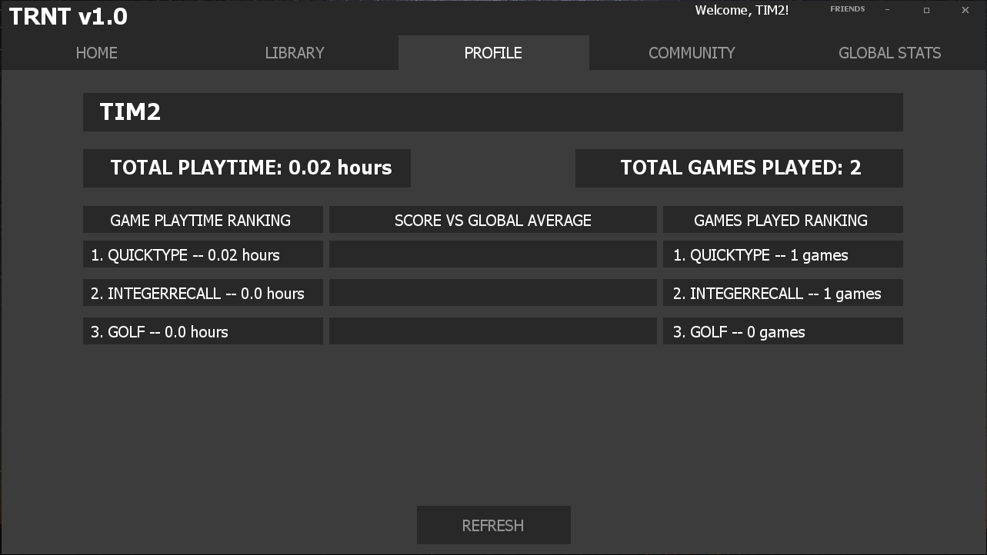

**Community Profiles**

To view people in the community’s profile, click on the tab labelled “COMMUNITY”, from here you can view other players profiles and request to add them as a friend or chat with them. To search for a player simply type the players name in the search box and click “FIND”.

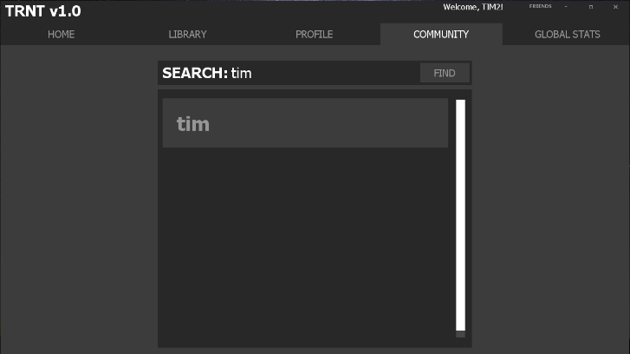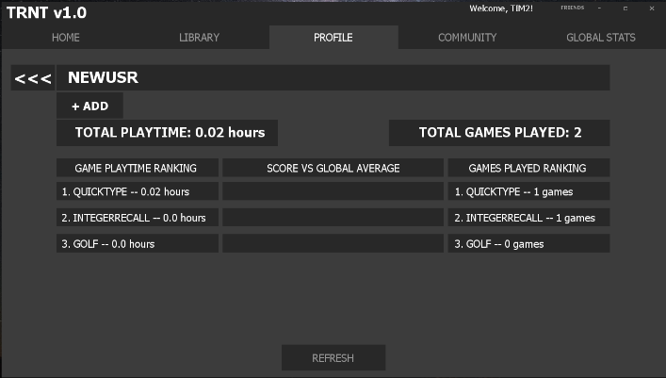

Adding Friends

**Adding a Friend**

To add a friend, you must navigate to that person profile from the “COMMUNITY” tab shown above. Once you have clicked into their profile simply click “+ ADD” and a friend request will be sent. If they accept the request, then you will both be added to each others friend list. Once someone is your friend all their scores will show up in your friend leaderboard and you will be able to chat with them.

**Viewing Your Friends**

To view your current friends, click on the “FRIENDS” tab near the top right corner of the launcher. Here you will see a list of all your friends. Clicking “P” will show you their profile and clicking “C” will open the chat window (Page 7). Please note that until someone has accepted your friend request they will not appear in your friend list. To view requests that you have received simply click on “REQUESTS” and you will be able to decline or accept the users request.

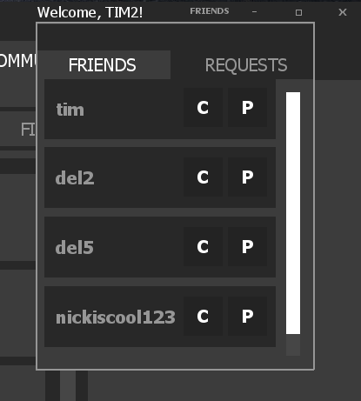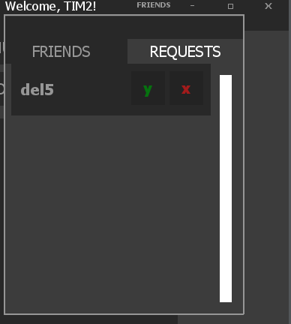

Global & Friend Leaderboards

**Global Leaderboards**

To view the global leaderboard simply navigate to the “GLOBAL STATS” page and select the game you would like to view. I will show you the top 5 scores for that game and tell you where you rank. These global leaderboards can also be seen within the game.

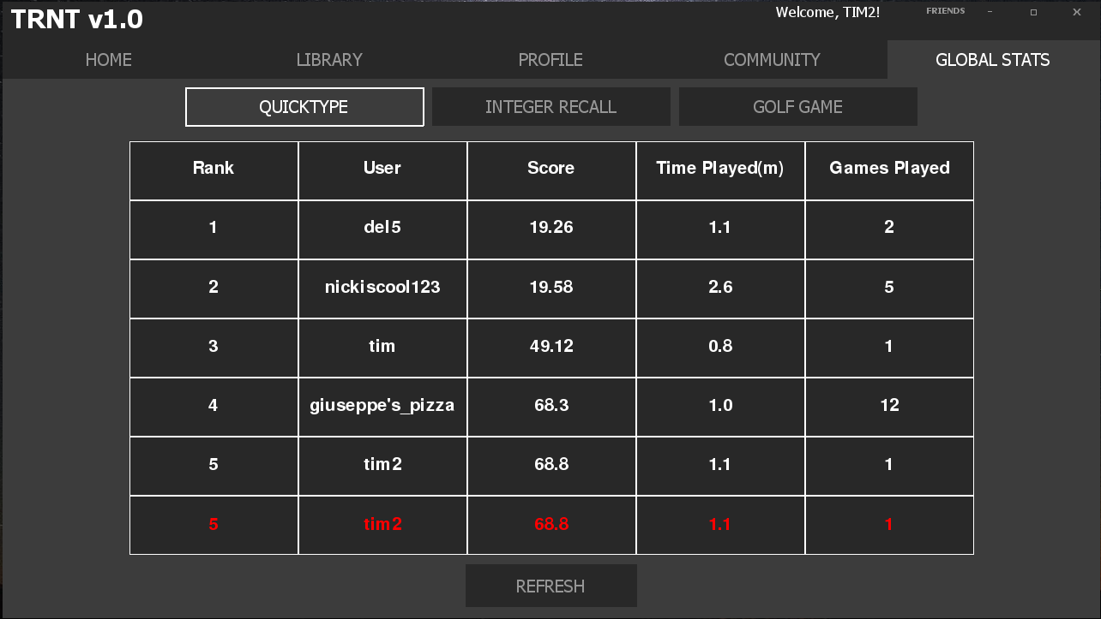

**Friend Leaderboards**

To view a leaderboard only populated by your friends click on the “LIBRARY” tab then select which game you would like to view on the right side. Scroll down on the page that appears and you will see a leaderboard. This can also be seen within the games.

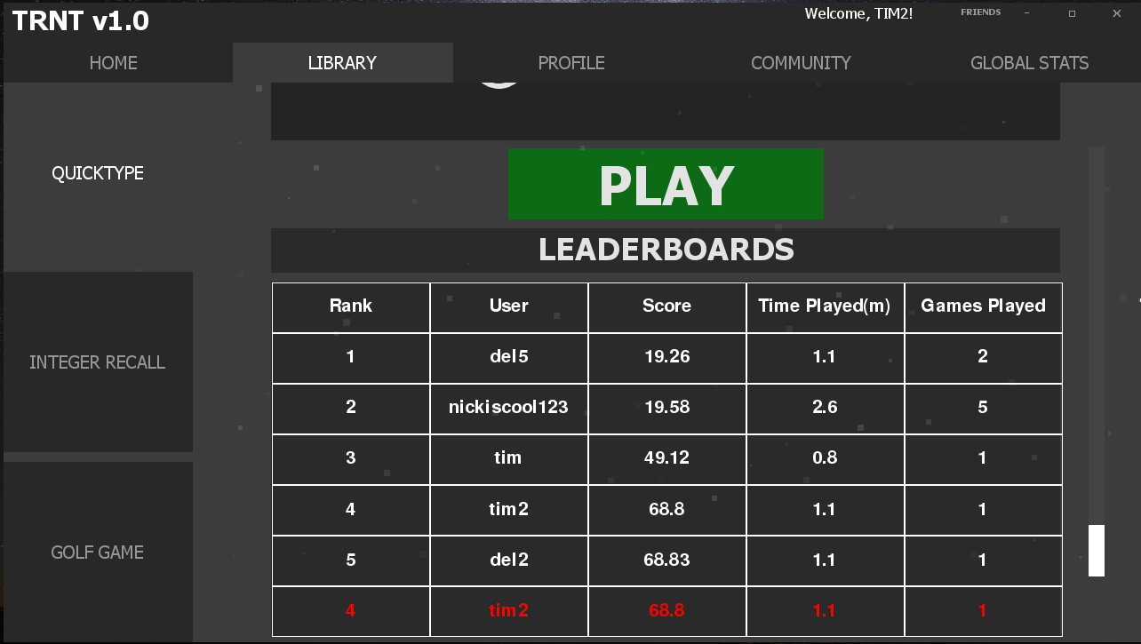

Instant Messaging

**Opening the Chat Window**

To open the chat window, you need to navigate to the “FRIENDS” tab, then press “C” on the profile of the friend you would like to chat with. A chat window will open where you can send and receive messages. You will not be notified if someone sends you a message and therefore to see messages you must check the chat window manually. You may only chat with people that are your friends.

**Sending Messages**

To send a message simply start typing your message and then hit the “SEND” button. There is a slight delay of about 5 seconds between when you send the message and when it will be received.

